ADVANCED DBMS LAB

Name : Rovy M Varghese

Roll No: 31

Batch: MCA B

Date 25/03/2022

EXPERIMENT 1

**AIM**

To study various DDL commands – CREATE,INSERT

**QUESTION**

Create the following Tables and Insert values

**Table 1: DEPOSIT**

ACTNO VARCHAR2(5) PRIMARY KEY, FIRST LETTER MUST START WITH ‘D’ CNAME VARCHAR2(15) FOREIGN KEY REFERENCES CUSTOMER

BNAME VARCHAR2(20) FOREIGN KEY REFERENCES BRANCH AMOUNT NUMBER (8,2) NOT NULL, CANNOT BE 0 ADATE DATE

**Table 2: BRANCH**

BNAME VARCHAR2(20) PRIMARY KEY CITY VARCHAR2(30) NOT NULL , any one of NAGPUR, DELHI, BANGALORE, BOMBAY

**Table 3: CUSTOMER**

CNAME VARCHAR2(15) PRIMARY KEY CITY VARCHAR2(20) NOT NULL

**Table 4: BORROW**

LOANNO VARCHAR2(8) PRIMARY KEY / FIRST LETTER MUST START WITH ‘L’ CNAME VARCHAR2(15) FOREIGN KEY REFERENCES CUSTOMER

BNAME VARCHAR2(20) FOREIGN KEY REFERENCES BRANCH AMOUNT NUMBER(8,2) NOT NULL, CANNOT BE 0

**PROCEDURE**

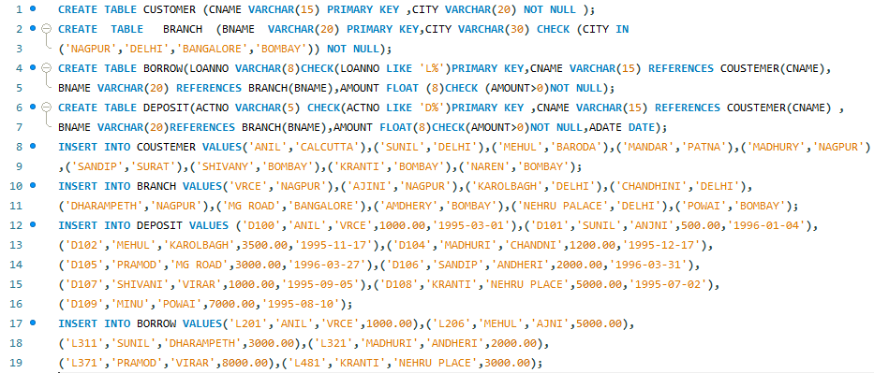

**OUTPUT**

**1.TABLE DEPOSIT**

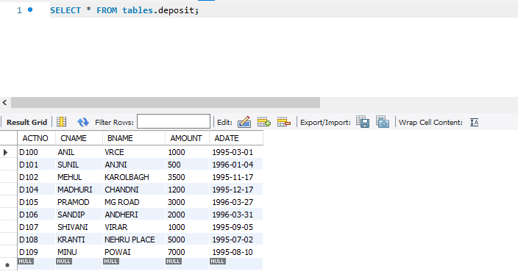

**2.TABLE BRANCH**

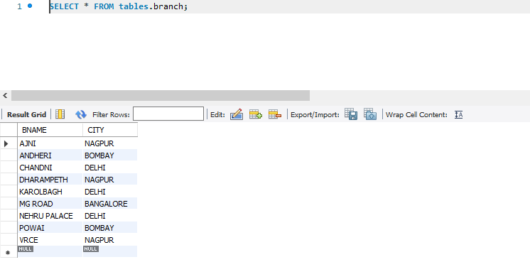

**3.TABLE CUSTOMER**

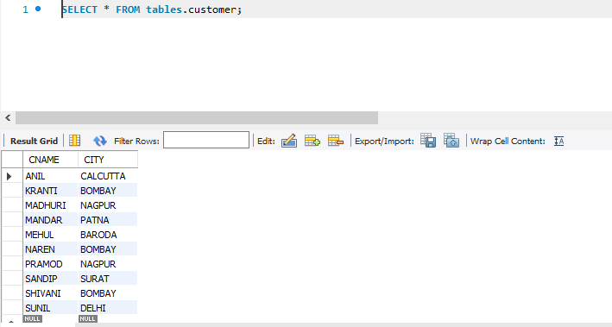

**4.TABLE BORROW**

